7 Minute Briefing

**Practice Learning Line of Sight Event - Child sexual abuse in the family environment**

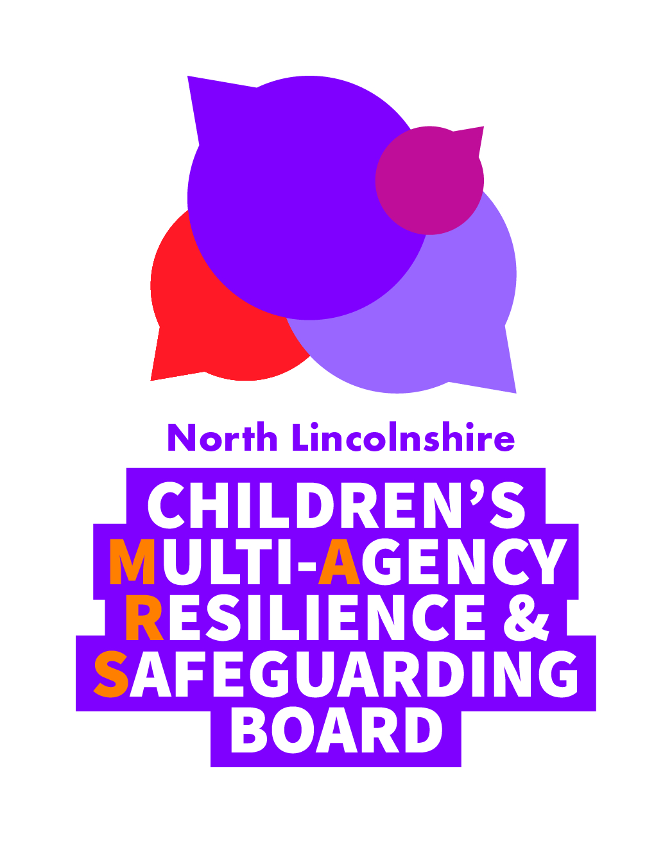

**1 Background**

North Lincolnshire Children’s MARS Board hold Practice Learning Line of Sight events three times a year across different themes. This is part of our [Scrutiny and Assurance Framework](http://www.northlincscmars.co.uk/learning-from-practice/).

After a process of single agency case audits, line of sight panels meet with practitioners to discuss a small number of cases. We identify areas of best practice also learning and further improvement relating to multi agency practice then agree strategic action.

**2 Why it matters?**

The Children’s MARS Board decided to focus on this theme as the Children’s Commissioner’s Inquiry gathered the most comprehensive evidence ever of child sexual abuse (CSA) in England and the report ‘Protecting children from harm: a critical assessment of child sexual abuse in the family network in England and priorities for action’ (2015) concluded that amongst other aspects:

* a focus of much of the activity has been CSA which occurs in institutions, and child sexual exploitation which occurs in communities. CSA which occurs within families has been largely absent from the national conversation.

**7 Further information**

* Working effectively with men in families – including fathers in children’s social care, Research in Practice July 2017
* Working effectively with men in families – practice pointers for including father’s in children’s social care, Research in Practice July 2017
* [Helping Children and Families (Threshold Document 2016/20)](http://www.northlincscmars.co.uk/policies-procedures-and-guidance/)

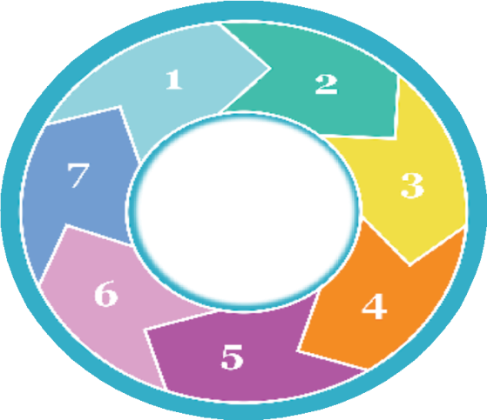

**Practice Learning Event**

**CSA in family environment**



**3 Good practice**

* Signs and symptoms were recognised and this can facilitate disclosure of CSA
* Specialist local training and self-directed learning enhanced evidenced based practice
* Utilising multi agency knowledge bases/skills made for better outcomes for children in complex family situations

**4 Key learning**

Highlighted

* Last time when we did a CSA Line of Sight (Nov 2017) CSA was a little taboo and we did not really talk about sexual abuse within the family. There was a change in focus this time in that practitioners and supervisors talked about it and knowledge was demonstrated across agencies

**6 Reflect on the learning**

To inform your practiceyou can

* Discuss with your supervisor taking a complex case to the Senior Safeguarding Solutions meeting - a forum for multi agency reflection and exploration of solutions in cases with multi faceted issues
* Take a look at the [CSA in the Family Environment toolkit](http://www.northlincscmars.co.uk/policies-procedures-and-guidance/)
* Book onto [Neglect or GCP2 training](http://www.northlincscmars.co.uk/training/)

**5 Top actions**

* Further develop opportunities to share learning, the use of research and evidence based practice especially in complex family situations
* Support workers tenacity when they do not know but suspect CSA within the family environment and access to research/models to help move things on
* Connection between neglect and CSA highlighted opportunities to link to GCP2
* Consider more the importance of men, their role within family networks and gender roles

**North Lincolnshire Children’s Multi Agency Resilience and Safeguarding (MARS) Board 2019**

[www.northlincscmars.co.uk](http://www.northlincscmars.co.uk)